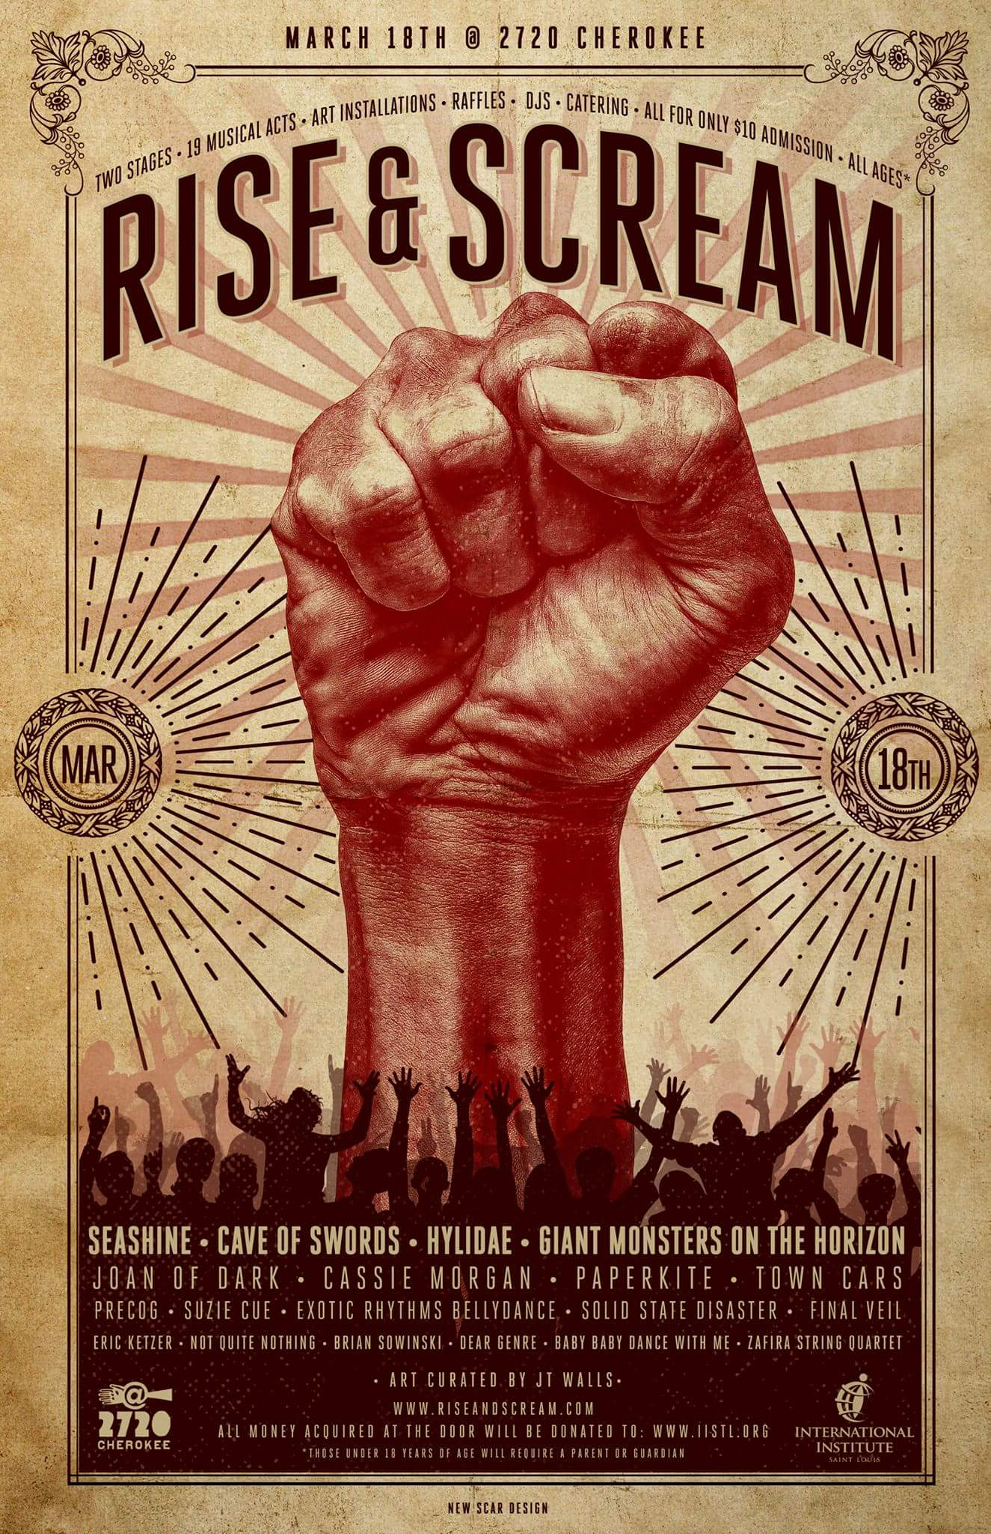

March 18th
Saturday 3:00 PM-1:00 AM

FEATURE EXHIBITION ENTRY FORM
APPLICATION DEADLINE: February 28th, 2017

Curator: JT Walls

Email: art@riseandscream.com

Description Of Exhibition: An invitational and juried exhibit of artwork to be on display during the fundraiser. Only two dimensional works are eligible. The art should have themes of anti-fascism and pro human rights. *Please no works promoting hate and violence* We will also have a few spots open for live art.
The Call for art is open to St Louis Metro area artists.

To Apply: Please read and complete the entire application. Failure to follow these directions will most likely prevent you from being chosen.

1. Complete this Entry Form and Feature Exhibition Disclaimer

2. Email application and files to art@riseandscream.com
**Make sure to include on the subject line “Rise & Scream Call For Art”

3. With your maximum of 3 digital files please include an artist bio, social media/website links and also photo of you. If you are chosen, this information will be used to promote the show and you as a guest artist.
Please do not submit work larger than 24x36 including frame (if applicable). Loose prints will not be accepted unless they are in a frame

4. You can apply to show your finished work in the gallery space, to show finished works AND be a live artist, or only be a live artist and show now finished works in the gallery space. Please indicate on the application below

Deadline:
Entry Deadline is February 28 2017.

The entries can have any date or origin and do not have to be from 20016/20017. Artists will be notified of their acceptance on or before March 6th, 2017. If accepted, a curator will follow up with any additional informational details regarding time of set-up, etc.
Drop off times will be sent with the acceptance email.



ARTIST ENTRY FORM
Rise & Scream Exhibition

DEADLINE: February 28th 2017

Name _________________________________ Date_______________________
Email ________________________ Phone number ________________________
Website ______________________ Address ______________________________
Medium ______________________ ______________________________

I am only interested in doing live art ______________________

I am interested in doing live art and submitting pieces to the exhibition ______________________

Submit up to 3 digital images representative of the work you would like to enter.
If only interested in being a live artist please submit examples or work
JPGs should be approximately 8X10 at 144ppi or 1152 pixels X 1449 pixels.
Name each JPG with your first initial, last name and the size of the entire piece including frame if applicable. Please submit all of these files in 1 email.
(example: JSmith_8x10.jpg JSmith_20x30.jpg, JSmith_20x24.jpg).

Image Number 1 (image file name)

Title___________________________________________________________

Medium_________________________________________________________

Size/Dimensions__________________________________________________

Date___________________________________________________________

Image Number 2 (image file name)

Title___________________________________________________________

Medium_________________________________________________________

Size/Dimensions__________________________________________________

Date___________________________________________________________

Image Number 3 (image file name)

Title___________________________________________________________

Medium_________________________________________________________

Size/Dimensions__________________________________________________

Date___________________________________________________________

Additional Artist Requirements:

1)________________________________________________________________

2)________________________________________________________________

3)________________________________________________________________

IMPORTANT Please Read

- All decisions of the curator/jurors are final.
- If you are accepted, by submitting your entry you give the right to publish your images for publicity purposes for the Rise & Scream fundraiser or as part of the art directory selected artists (All credits to artist will be included). We may ask select artists to provide higher resolution jpegs suitable for publishing.
- Select artists may be highlighted in the Facebook events page the riseandscream.com blog and robotsdestroy.com blog as well as and social media promotions
- There is a $20 free for accepted artist that covers entry for the gallery and/or entry for live art. This entry is donated directly to the fundraiser.
- The fundraiser and event space will not be taking commission for art sold. The artist will be in charge of handling any transactions or questions about selling the art. Since this is a 1 night even art can be removed as soon as it’s purchased.
- Artists chosen for live art are recommended to paint from at least 5pm-10pm however are welcome to work the entire time. Live artists are also welcome and encouraged to sell to piece they’re painting.

March 18th
Saturday 3:00 PM-1:00 AM

FEATURE EXHIBITION DISCLAIMER

*Required for Participation in the Exhibitions of the 2017 Rise & Scream Fundraiser
Please sign and submit this form with your artwork

I, the undersigned, hereby lend the following work (s) or other materials to Rise & Scream Fundraiser for exhibition purposes only for the Rise & Scream exhibition. I hereby release the Rise & Scream Fundraiser, curators and organizers from any responsibility for loss or damage while the work (s) is in possession of the Rise & Scream Fundraiser art exhibition.

The Rise & Scream Fundraiser art exhibition is to be held at 2720 Cherokee Performing Arts Center.

Thank you and good luck artists!

Name ______________________________ Address _______________________________

Phone______________________________ Email _________________________________

Website _____________________________________________________________________

Signature ___________________________________ Date_______________________

